ER Diagram

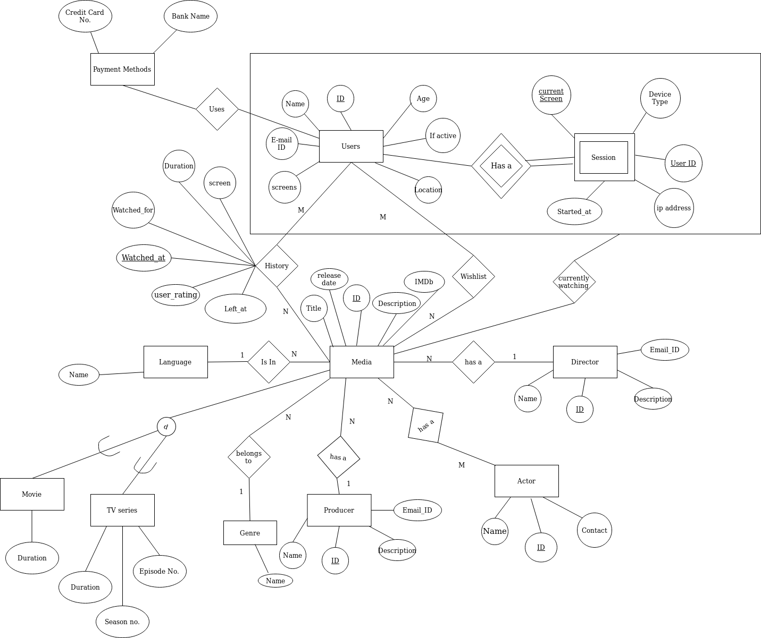

Relational Schema

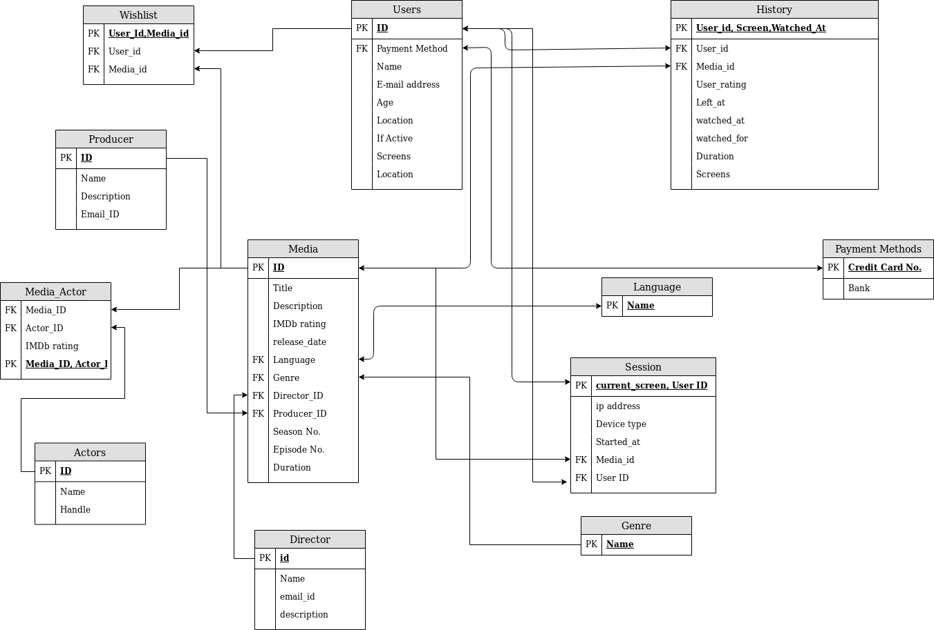

Minimal FD set and BCNF

**RELATION(R1): USERS(User_ID, Name, Email_ID, Age, Location, screens, If active, Payment Method)**

User_ID →Name

User_ID →Email_ID

User_ID →Age

User_ID →Location

User_ID →screens

User_ID →If active

USER_ID →Payment Method

**It is BCNF.**

**RELATION(R2): MEDIA(Media_ID, Title, Description, IMDb rating, release_date, Language, Genre_ID, Director_ID, Producer_ID, Season No, Episode No., Duration)**

Media_ID → Title

Media_ID → Description

Media_ID → IMDb rating

Media_ID → release_date

Media_ID → Language

Media_ID → Genre_ID

Media_ID →Director_ID

Media_ID →Producer_ID

Media_ID →Season No.

Media_ID →Epsiode No.

Media_ID →Duration

**It is BCNF.**

**RELATION(R3): Actors(ID, Name, Contact, Description)**

ID → Name

ID →Contact

ID →Description

**It is BCNF.**

**RELATION(R4): Media_Actors(Media_ID, Actor_ID, IMDb rating)**

Media_ID, Actor_ID →IMDb rating

**It is BCNF.**

**RELATION(R5): Director(ID, Name, Email-ID, Description)**

ID →Name

ID →Email-ID

ID →Description

**It is BCNF.**

**RELATION(R6): Producer(ID, Name, Email_ID Description)**

ID →Name

ID → Email_ID

ID →Description

**It is BCNF.**

**RELATION(R7): Wishlist(User_ID, Media_ID)**

**It is BCNF.**

**RELATION(R8): Session(Current_screen, UserID, IP_Address, Device type, Started_At, Media_ID)**

Current_screen, UserID→ IP_Address

Current_screen, UserID→Device type

Current_screen, UserID→Started_At

Current_screen, UserID→Media_ID

**It is BCNF.**

**RELATION(R9): Language( Language)**

**It is BCNF.**

**RELATION(10): Genre( Name)**

**It is BCNF.**

**RELATION(R11): History(User_id, Screen, Watched_at, Media_ID, User_rating, Left_at, Watched_for)**

{User_id, Screen, Watched_at} →Media_ID

{User_id, Screen, Watched_at} →User_rating

{User_id, Screen, Watched_at} →Left_at

{User_id, Screen, Watched_at} →Watched_for

**It is BCNF.**

**RELATION(R12): Payment Methods(Credit Card No., Bank)**

Credit Card No. →Bank

**It is BCNF.**